Introduction to Electromagnetism

By

Prof. Manoj K. Harbola

Department of Physics

Indian Institute of Technology, Kanpur

Lecture - 01

Coulomb’s Law

This is a course on Electromagnetic Theory and any courses starts with Coulomb's Law.

(Refer Slide Time: 00:24)

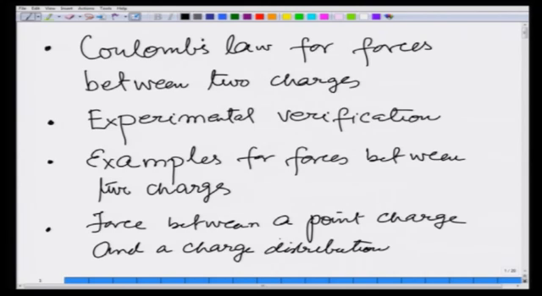

So, we start with Coulomb's law for forces between two charges. Then, we are going to see how this can be confirmed that this is really true with experimental verification. Third, then we are going to solve some examples for forces between two charges. And finally, in this lecture, we are going to talk about the force between a point charge and a charge distribution. This is the program for this lecture and based on what we cover today I am also going to give you an assignment, where you solve three or four problems employing these concepts.

(Refer Slide Time: 02:07)

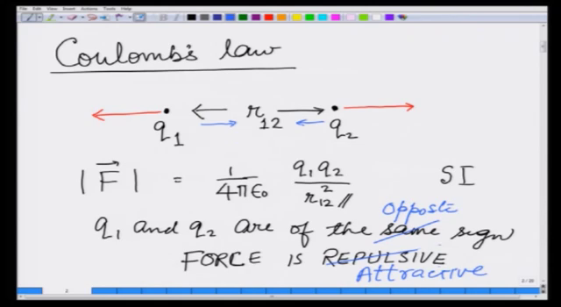

So, what Coulombs' law says is that if there are two charge points, let us take them to be point charges right now. So, there is a charge q1 and another charge q2 separated by a distance r and for the future, because I am going to develop a notation also. Let us write this as r12 that indicates the distance between charge 1 and charge 2. Then, the force between them is the magnitude force. Of course, you know from your Mechanics course that force is a vector quantity.

The force between them is the magnitude which is going to be equal to on what units we are going to choose for q 1 and q 2. Finally, it is the SI units that we work in. So, I am going to write this in terms of this SI units, it is going to be 4 pi Epsilon 0 where Epsilon 0 is known as the permittivity of vacuum q 1, q 2 over r 1 2 square. That means, the distance between two charges is doubled, because of the square out given hereunder:

$$\vec{\left|F\right|}=\frac{1}{4πε_{0}}\frac{q_{1}q_{2}}{r_{12}^{2}}$$

If there is a square out as above, the force would be going to become less by a factor of four, but I just said forces are not only the quantity but also the magnitude. It has also a direction of the force.

You learnt in your previous classes that, if q1 and q2 are of the same sign, then the force is repulsive. What it means is that, the force is going to be along the same lines as the line joining the charges and they are going to repel each other and the magnitude being the same.